GENERAL CONFEDERATION OF LABOR OF VIETNAM

**TON DUC THANG UNIVERSITY**

**FACULTY OF INFORMATION TECHNOLOGY**



**THE FINAL PROJECT OF SOFTWARE TECHNOLOGY**

**Management software for dietary supplement’s retailing company**

*Instructing Lecturer*: **ĐẶNG MINH THẮNG**

*Student’s name*: **PHÙ PHƯƠNG TÍN – 518H0675**

**NGUYỄN QUANG TUẤN – 518H6082**

*Class* **: 18H50302**

*Course*  **: 22**

**THÀNH PHỐ HỒ CHÍ MINH, NĂM 2022**

GENERAL CONFEDERATION OF LABOR OF VIETNAM

**TON DUC THANG UNIVERSITY**

**FACULTY OF INFORMATION TECHNOLOGY**



**THE FINAL PROJECT OF SOFTWARE TECHNOLOGY**

**Management software for dietary supplement’s retailing company**

*Instructing Lecturer*: **ĐẶNG MINH THẮNG**

*Student’s name*: **PHÙ PHƯƠNG TÍN – 518H0675**

**NGUYỄN QUANG TUẤN – 518H6082**

*Class* **: 18H50302**

*Course*  **: 22**

**THÀNH PHỐ HỒ CHÍ MINH, NĂM 2022**

**ACKNOWLEDGEMENT**

First of all, I would like to sincerely thank the enthusiastic support of the lecturers and classmates for me to have a complete and good report like this.

Our team would like to sincerely thank Mr. Dang Minh Thang for supporting, giving us instructions and advice and useful knowledge to give us in the process of studying and implementing this project.

Also, thanks to Faculty of Information Technology and Ton Duc Thang University for giving us a modern and developed educational environment.

We have completed this report well with hard work and efforts. However, this report cannot be a perfect report, it must contain some errors. We hope to receive feedback from teachers so that we can improve it better.

Sincere!

**ĐỒ ÁN ĐƯỢC HOÀN THÀNH**

**TẠI TRƯỜNG ĐẠI HỌC TÔN ĐỨC THẮNG**

Tôi xin cam đoan đây là sản phẩm đồ án của riêng tôi / chúng tôi và được sự hướng dẫn của thầy Đặng Minh Thắng. Các nội dung nghiên cứu, kết quả trong đề tài này là trung thực và chưa công bố dưới bất kỳ hình thức nào trước đây. Những số liệu trong các bảng biểu phục vụ cho việc phân tích, nhận xét, đánh giá được chính tác giả thu thập từ các nguồn khác nhau có ghi rõ trong phần tài liệu tham khảo.

Ngoài ra, trong đồ án còn sử dụng một số nhận xét, đánh giá cũng như số liệu của các tác giả khác, cơ quan tổ chức khác đều có trích dẫn và chú thích nguồn gốc.

**Nếu phát hiện có bất kỳ sự gian lận nào tôi xin hoàn toàn chịu trách nhiệm về nội dung đồ án của mình.** Trường đại học Tôn Đức Thắng không liên quan đến những vi phạm tác quyền, bản quyền do tôi gây ra trong quá trình thực hiện (nếu có).

*TP. Hồ Chí Minh, ngày tháng năm*

*Tác giả*

*(ký tên và ghi rõ họ tên)*

*Phù Phương Tín*

*Nguyễn Quang Tuấn*

**SUMMARY**

We decided to do the project as soon as possible because we don't have much experience and knowledge about this project. We learned about system architecture and development model together and choose what we think is right for the project. We ended up choosing to do this project based on the agile model to both design and develop the user interface screens while improving the functionality and learning more about both how to solve the problems we are encountered.

**TABLE OF CONTENTS**

ACKNOWLEDGEMENT 1

SUMMARY 3

TABLE OF CONTENTS 4

Chapter 1: Introduction 6

1.1. Purpose and Scope 6

1.2. Product Overview 6

Chapter 2: Project Management Plan 7

2.1. Project Organization 7

2.2. Waterfall Model 7

2.3. Risk Analysis 9

2.4. Hardware and Software Resource Requirements 9

2.5. Deliverables and Schedule 9

Chapter 3: Requirement Specification 11

3.1. Stakeholders for the system 11

3.2 Use case model 11

3.2.1 Graphical use case model 11

3.3 Functional requirements  14

3.4 Non-Functional requirements  14

Chapter 4: Design 16

4.1 Architecture 16

4.2 Database design 17

4.3 class diagrams 18

4.4. sequence diagrams 18

4.4.1. Register 18

4.4.2. Login 19

4.4.3. Retailer order 19

4.4.4. Retailer view order history 20

4.4.5. Create a import form 20

4.4.6. Create a export form 21

4.4.7. View import/export history 21

4.4.8. View and change order status 22

Chapter 5: Demo 23

5.1. Link source code (git): 23

5.2. Link video demo: 23

5.3. Design interface 23

5.3.1. login page 23

5.3.2. register page 23

5.3.3. retailer order page 24

5.3.4. Retailer order history page 25

5.3.5. Accountant import/export page 26

5.3.6. Accountant manage order page 27

5.3.7. import/export history page 27

Scoring Criteria: 30

REFERENCES 33

**Chapter 2: Project Management Plan**

**2.1. Project Organization**

The project will be divided into to 8 step:

* Do the documentation. List the functions, user case, basic requirements
* Re-validate the system's functions and requirements
* Create class diagrams, database, sequence diagram.
* Determine the language and technology to implement the project (the advantages that this language/technology brings compared to other languages/technology)
* Project coding
* Testing
* Project implement
* Maintenance

**2.2. Waterfall Model**

In this project we use waterfall model

**Model analysis:**

* Requirement gathering: Requirements gathering and analysis A company selling functional facts to agents needs software in during this phase.
* System Analysis: Analyze and design software systems, determine the overall system architecture of the software.
* Coding: The system is developed by unit and integrated in the next phase. Each Unit developed and tested by the dev is called a Unit Test.
* Testing: Install and test the software. The main job of this phase is to check and correct all the errors found so that the software works correctly and according to the requirements specification document.
* Implementation: Deploy the system in a customer environment and bring it to market.
* Operations and Maintenance: Maintain the system when there are any changes from customers and users.

All these phases are cascaded to each other in which progress is seen as flowing steadily downwards (like a waterfall) through the phases. The next phase is started only after the defined set of goals are achieved for previous phase and it is signed off. And in this model, phases do not overlap.

We chose Waterfall model because:

* Requirements are very well documented, clear and fixed
* Product definition is stable.
* The project is short.

**Advantages of the Waterfall Model are as follows :**

* Simple and easy to understand, easy to use and easy to manage.
* Works well for smaller projects where requirements are very well understood.
* Clearly defined stages.
* Easy to arrange tasks.
* Process and results are well documented.
* Validation at each stage, ensuring early detection of defects

**Disadvantages of the Waterfall Model are as follows :**

* Less flexibility, limited adjustment range.
* It is difficult to measure development in each stage.
* The model is not suitable for changes in requirements during the development life cycle.
* Difficult to return once a certain period has ended

**2.3. Risk Analysis**

* No products are produced until the end of the life cycle.
* High risk and uncertainty if there is a change in requirements.
* It is difficult to measure progress in stages.
* Cannot reply to the change request.

**2.4. Hardware and Software Resource Requirements**

Software model: MVC model

          Coding repository : Github

          Frontend: HTML, CSS, JavaScript, JQuery, EJS

          Backend: ExpressJS, Mongoose.

          Database: MongoDB, Mongo Atlas

          Hosting: Heroku

**2.5. Deliverables and Schedule**

Deliverables : Before 16/01/2022, we must finish all the project (Document must done, software is able to used).

Schedule:

* November 29th 2021, determine the model for project, list the functions, user case, basic requirements
* December 5th, re-validate the system's functions and requirements and complete the work done in the report
* December 7th create repository on git, class diagrams, database, sequence diagram and complete the work done in the report
* December 9th, determine the architecture, language and technology to implement the project
* December 11th 2021 to January 4th 2022 , coding user interface and system function
* January 8th, create test case and testing
* January 8th to 15th, fixing bug, improved interface and functionality
* January 15th to 16th, finalize products and reports

**Chapter 3: Requirement Specification**

**3.1. Stakeholders for the system**

Primary stakeholders:

* Customer ( Pharmacy company )
* Business Analyst

Project team:

* Project manager
* UI/UX Designer
* Developers

Secondary stakeholders:

* End users
* Competitors
* Government

**3.2 Use case model**

|  |  |
| --- | --- |
| **Actors** | **Description** |
| Accountant  (Kế toán) | Keep the numbers of products in the warehouse updated.  Inform the retailers on their deliveries and request them to complete their payments if needed.  Have the ability to see warehouse statistics and the company’s monthly income. |
| Retailers (Đại lý) | A retailer can create a request to purchase products. |

**3.2.1 Graphical use case model**

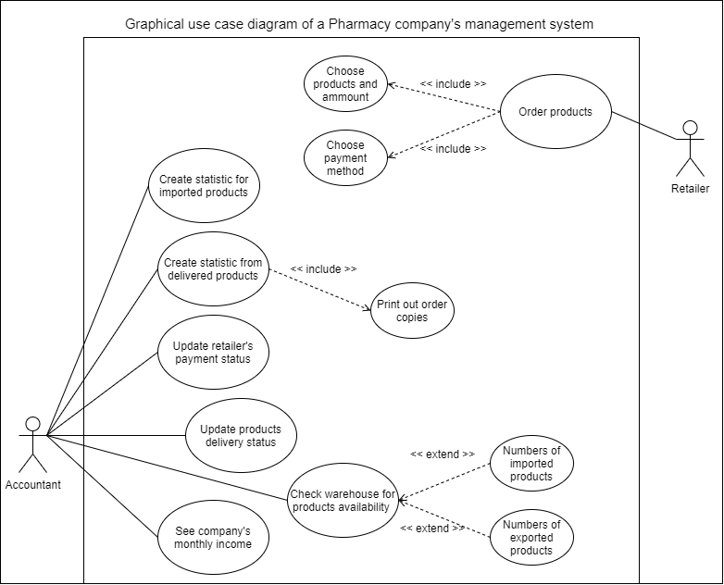  
  
  
**3.2.2 Textual Description for each use case**

**Use case #1:**

|  |  |  |
| --- | --- | --- |
| **Use case** | A retailer wants to purchase some products from the pharmacy company’s website. | |
| **Actor** | Retailer | |
| **Goal** | To create an order to purchase some products. | |
| **Overview** | A retailer has a shortage of products, they request an order for some products from the pharmacy company’s website. | |
| **Typical course of events** | Actor action  1. Login to their account.  4. Starts adding products and amounts to cart  5. Proceeds to the checkout section  7. Fills in information and address  8. Add payment method | System response  2. Check for login authentication  3. Redirect to the ordering page    6. Redirect to the checkout page    9. Order information is stored into the database. |
| **Alternative courses**  **Step 1** | The user doesn’t  have an account and is required to create one to be able to purchase products. | |

**Use case #2:**

|  |  |  |
| --- | --- | --- |
| **Use case** | A retailer wants to purchase some products from the pharmacy company’s website.  The accountant creates a delivery order to send the products to the retailer. | |
| **Actor** | Accountant | |
| **Goal** | To create a delivery order to the retailer and update the warehouse’s products’ number. | |
| **Overview** | The system informs the accountant that there is an order from a retailer. The accountant will then create a file to be able to take and update products’ quantity in the warehouse that will be delivered to the retailer. | |
| **Typical course of events** | Actor action  1. Login to their account.  4. Reads the retailer product’s order  5. Create a request to export the products from the warehouse  7. Create a delivery to the retailer  8. Print a copy of the order | System response  2. Check for login authentication  3. Redirect to the orders managing page    6. System checks database for products availability |

**3.3 Functional requirements**

* A retailer can create an order to buy multiple products.
* An accountant shall be able to see incoming orders, the warehouse’s product quantity and the company monthly incomes.
* An accountant can create a request to take out or import new products into the warehouse.
* An accountant can update delivery status and the retailer payments.

**3.4 Non-Functional requirements**

* The retailer can either choose their payment method during ordering or choose later when the products are being delivered.

**Chapter 4: Architecture**

## 4.1 Architectural style(s) used

* Client - Server architecture:
* In our project specifically, we use 2 cloud hosting services for deployment and database management.

## 4.2 Technology, software and hardware used

          Software model: MVC model

          Coding repository : Github

          Frontend: HTML, CSS, JavaScript, JQuery, EJS

          Backend: ExpressJS, Mongoose.

          Database: MongoDB, Mongo Atlas

          Hosting: Heroku

## 4.3 Rationale for your architectural style and model

This application will be implemented as a web application so that any user with a technology device that has an internet connection and an internet browser can easily access and interact with our application.

Our group has made a decision to implement the web application using the following technologies:

|  |  |
| --- | --- |
| Architectural style: Client - Server architecture | Client-server architecture is most useful for applications that require a separation or abstraction of concerns between the client and the server |
| Software model: MVC model | MVC model can help with faster development process especially when working with view and controller separately |
| Coding repository : Github | Github allows coders’ collaboration, any piece of code can be shared and modified without compromising the integrity of the original projects. |
| Frontend: HTML, CSS, JavaScript, JQuery, EJS. | Basic structuring and themes using HTML and CSS  Basic interaction between document elements and sending client requests to server using Javascript and JQuery’s Ajax.  EJS is a tool for generating web pages that can include dynamic data. This can help render the Javascript variable on to the web page by directly putting the JS variable into the EJS bracket. |
| Backend: NodeJS, ExpressJS, Mongoose. | Node.js is easily employed as a server-side proxy where it can handle a large amount of simultaneous connections in a non-blocking manner.  ExpressJS is a prebuilt NodeJS framework that can help you in creating server-side web applications faster and smarter.  Mongoose is an Object Data Modeling (ODM) library for MongoDB and Node. js. It manages relationships between data. |
| Database: MongoDB | MongoDB is NoSQL and has flexible schema makes it easy to evolve and store data. |
| Hosting: Heroku, MongoDB Atlas | Heroku is a free cloud hosting service that can help you deploy, manage, and scale modern apps.  MongoDB Atlas is also a free cloud hosting service that can help simplifies deploying and managing your databases. |

**Chapter 5: Design**

**5.1 Architecture model**

**UML**

Class diagram

Sequence diagram

Activity diagram

**5.2 Database design**

The database type that this project uses is NoSQL type, since NoSQL is developer friendly and it is much easier to make updates.

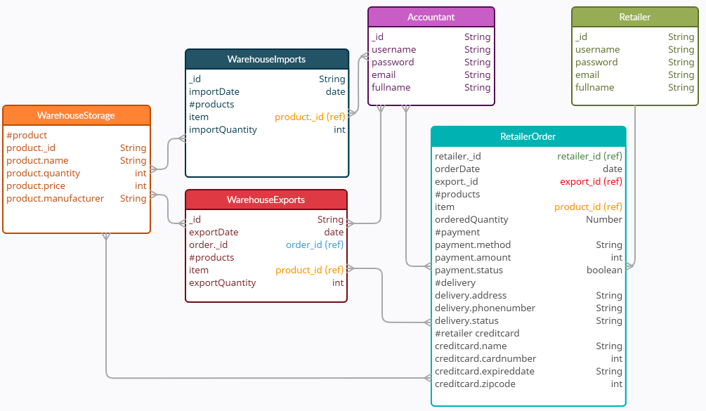

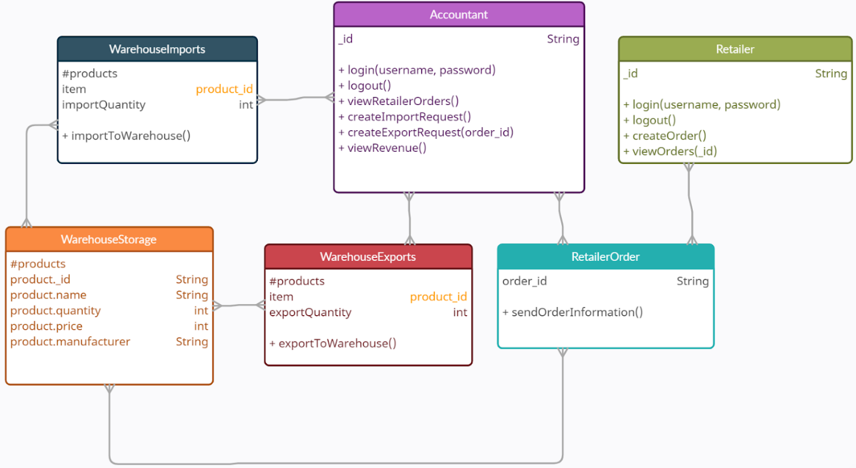**5.3 class diagrams**

**5.4. sequence diagrams**

**5.4.1. Register**

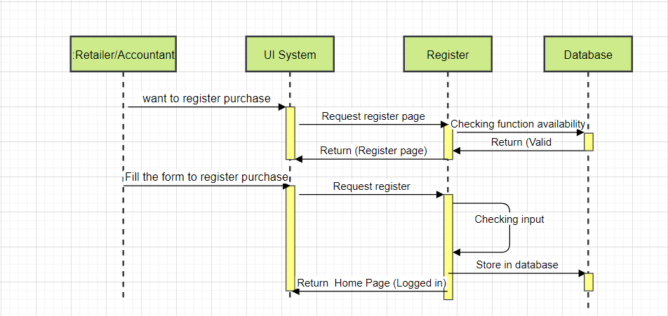

**5.4.2. Login**

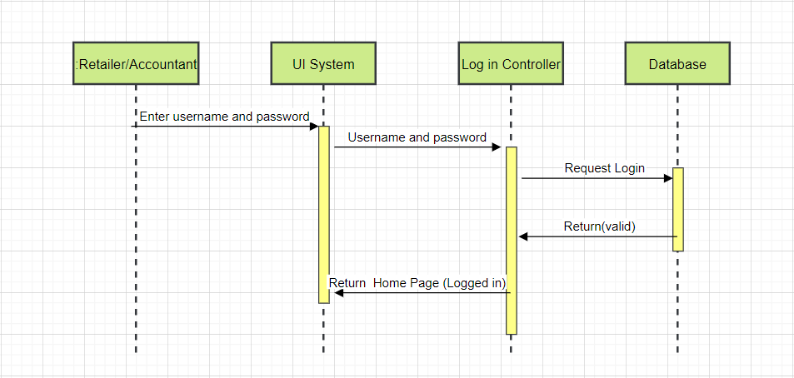

**5.4.3. Retailer order**

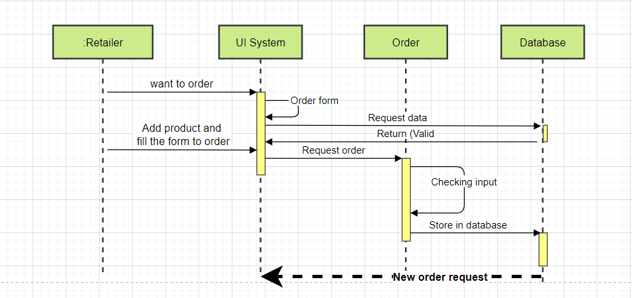

**5.4.4. Retailer view order history**

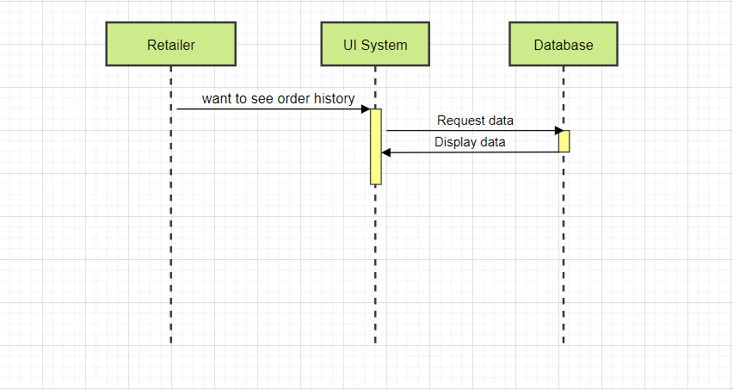

**5.4.5. Create a import form**

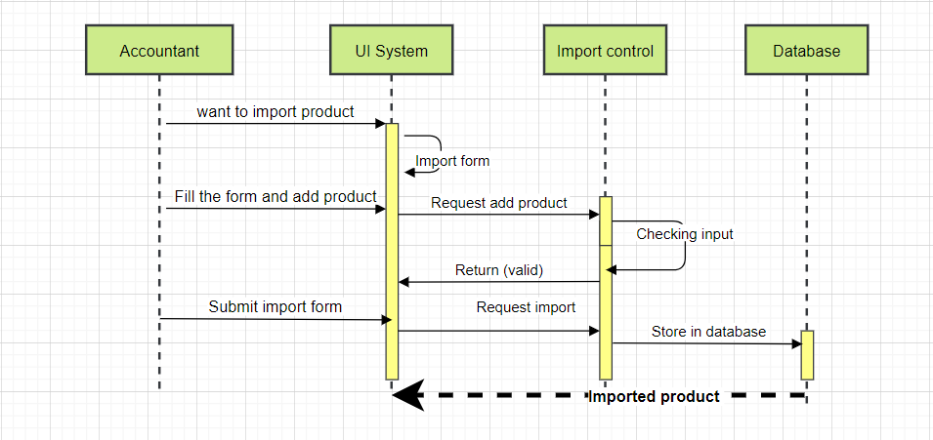

**5.4.6. Create a export form**

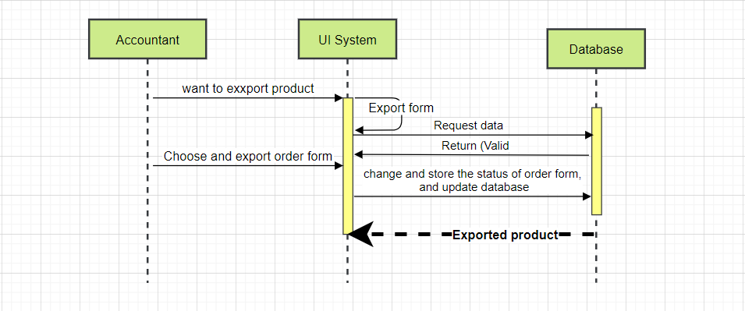

**5.4.7. View import/export history**

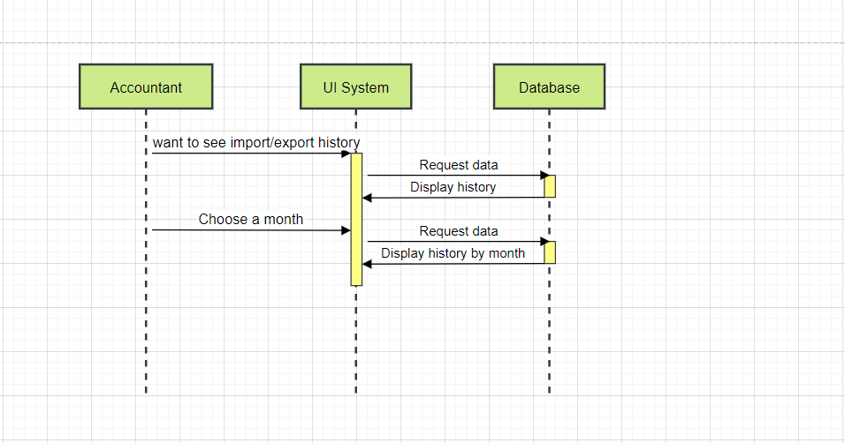

**5.4.8. View and change order status**

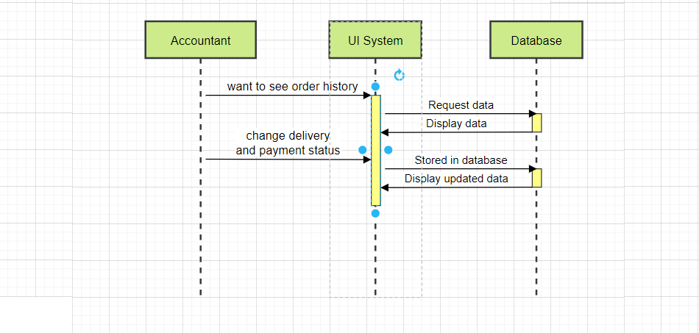

**Chapter 6: Demo**

**6.1. Link source code (git):**

[**https://github.com/Yosutta/CKCNPM**](https://github.com/Yosutta/CKCNPM)

**6.2. Link video demo:**

**6.3. Design interface**

**6.3.1. login page**

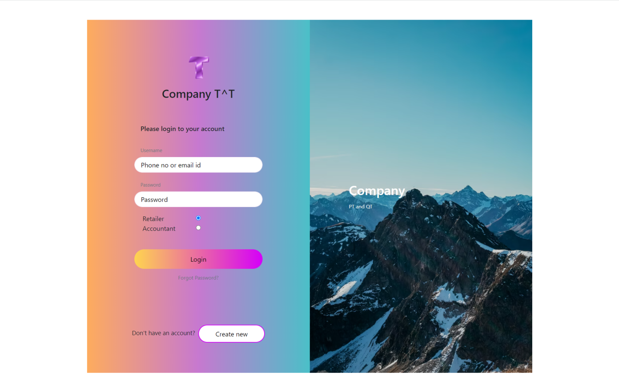

**6.3.2. register page**

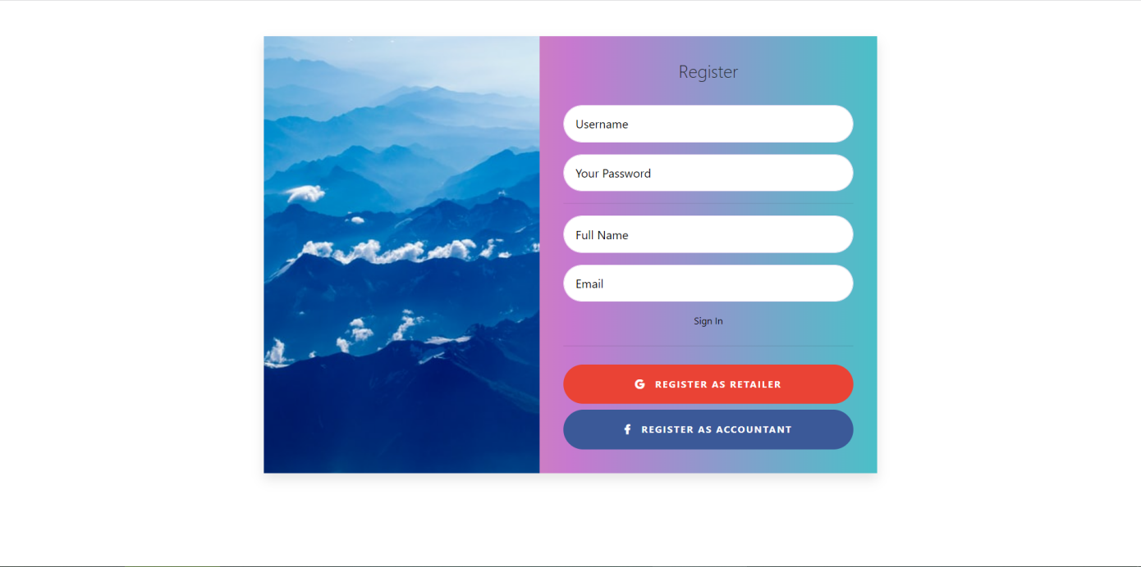

**6.3.3. retailer order page**

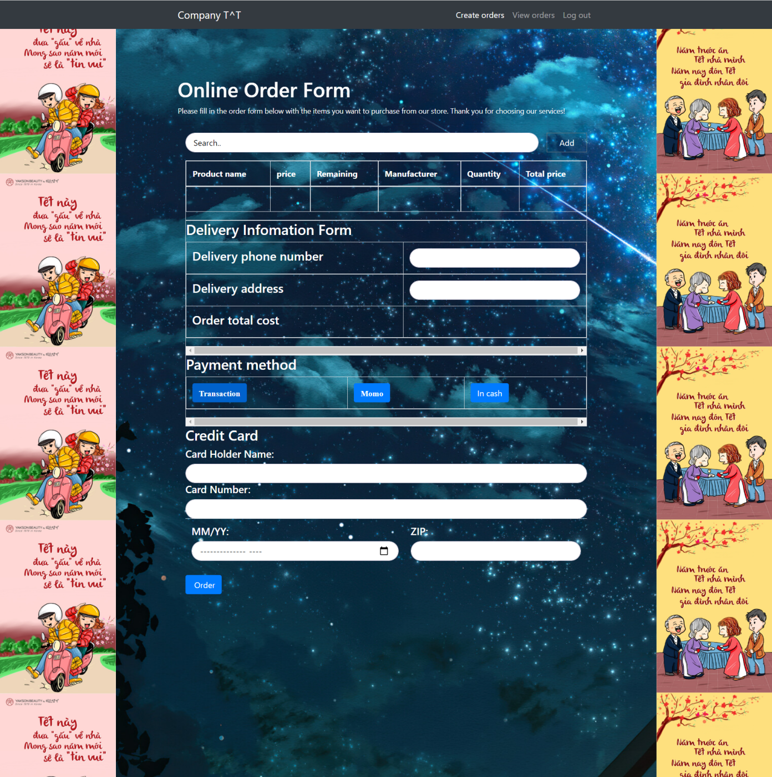

**6.3.4. Retailer order history page**

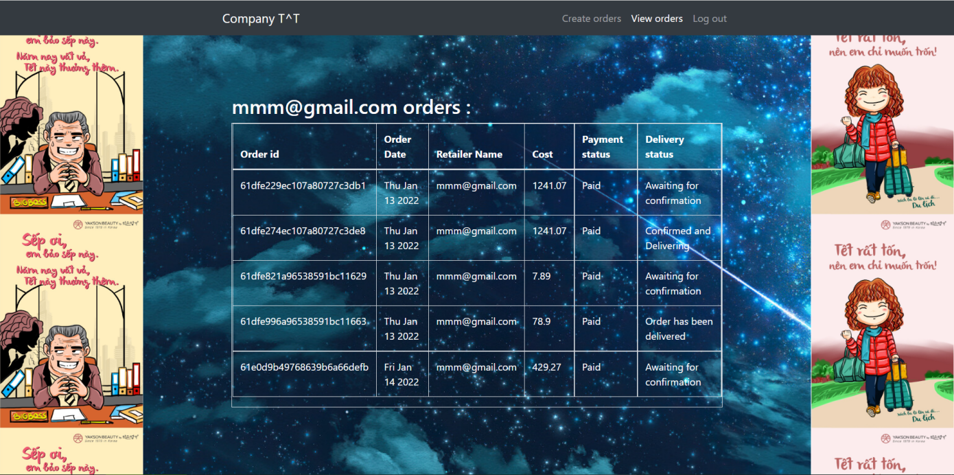

**6.3.5. Accountant import/export page**

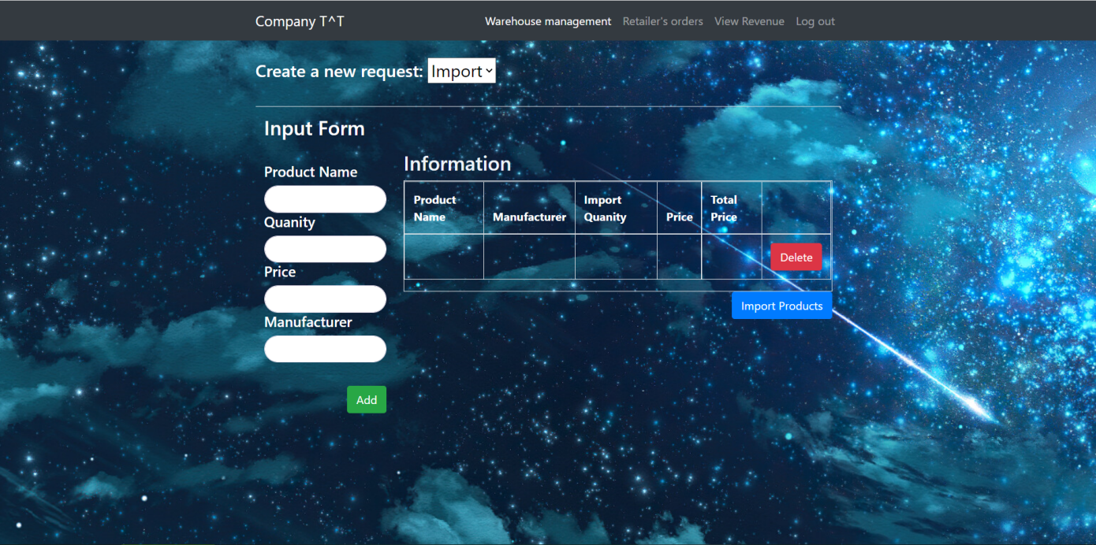

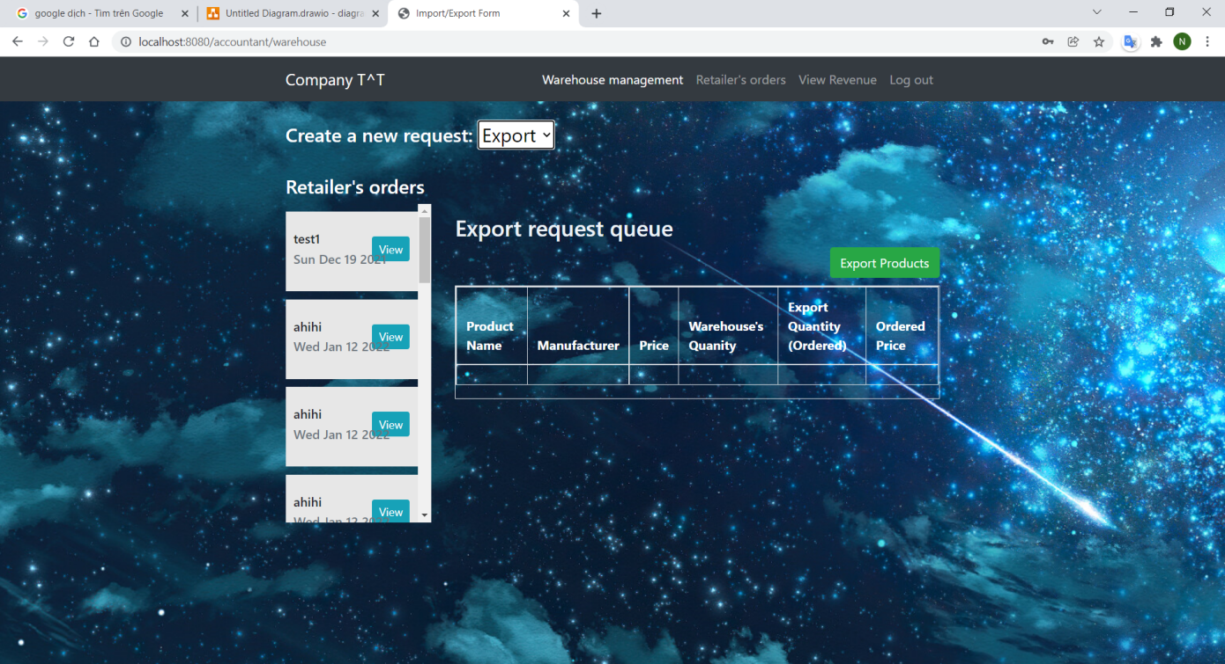

**6.3.6. Accountant manage order page**

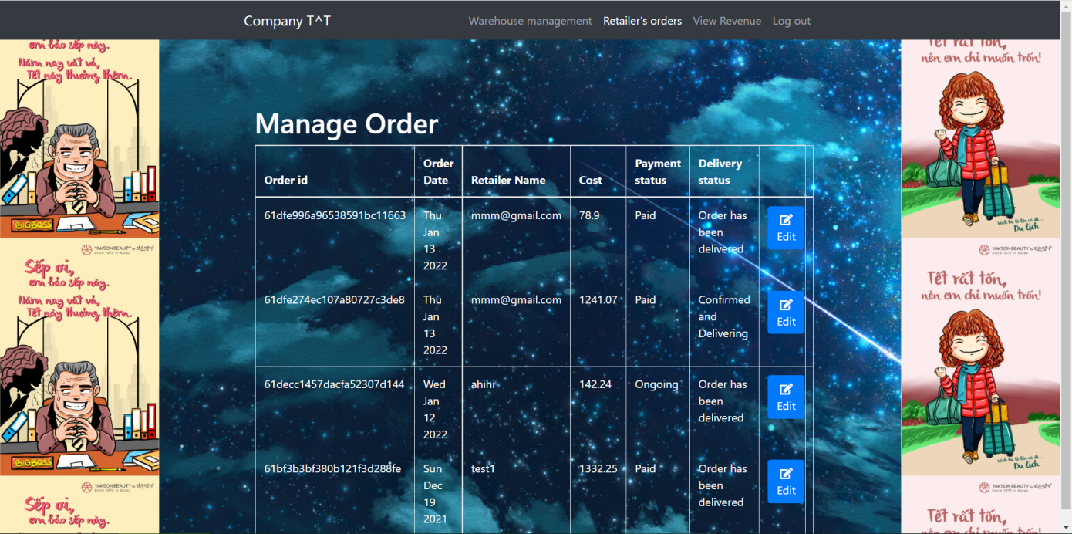

**6.3.7. import/export history page**

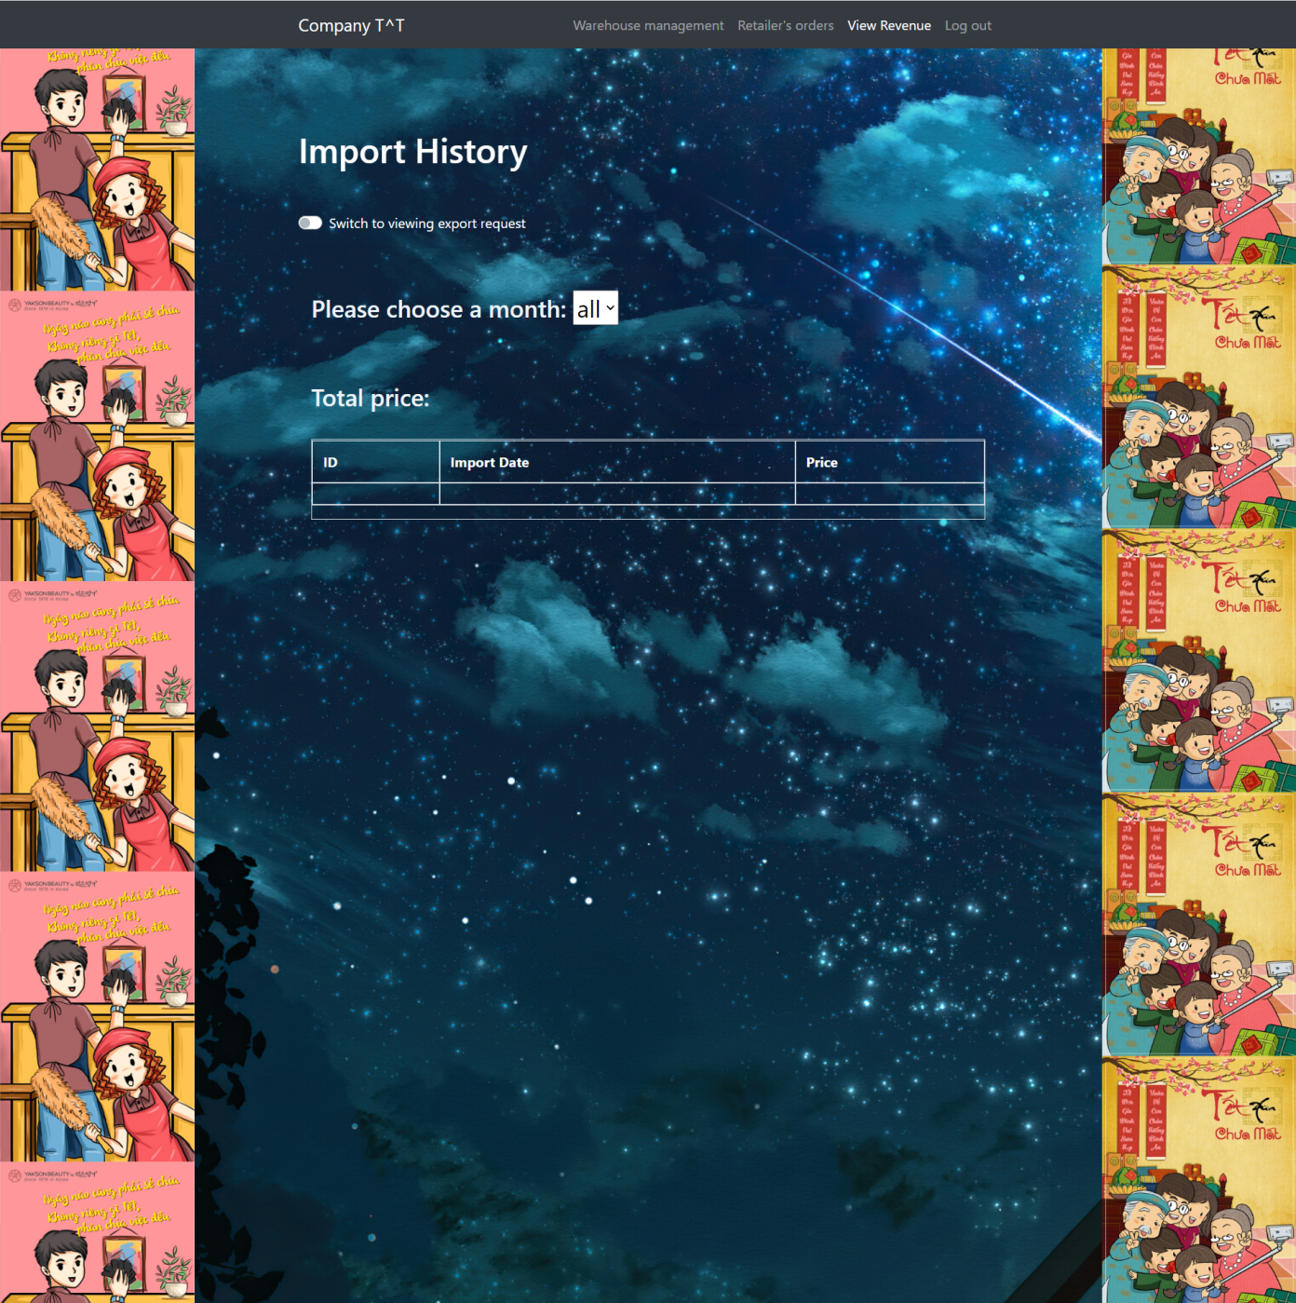

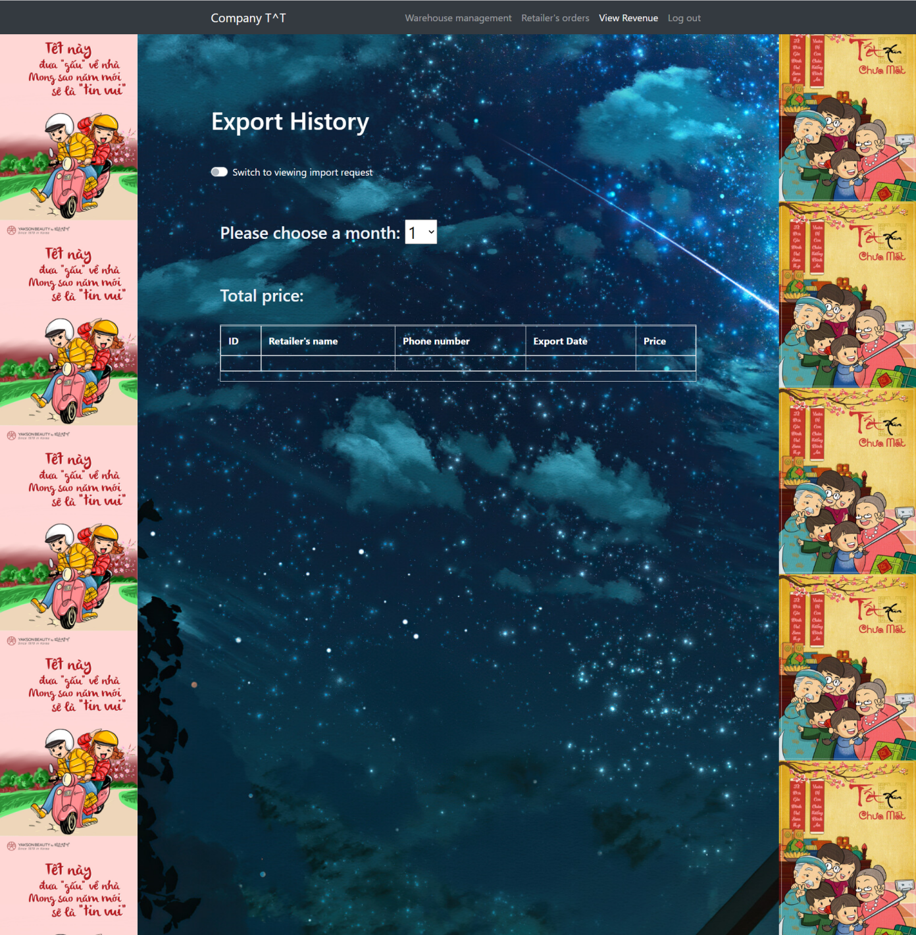

# Scoring Criteria:

|  |  |  |  |  |  |
| --- | --- | --- | --- | --- | --- |
| **Nội dung tiêu chí** | **Thang đánh giá** | **1** | **2** | **3** | **Self evaluation** |
| **Điểm /10** | **0-0.25 điểm** | **0.25-0.75** | **0.75-1.0** |  |
| **1/ Project Management Plan**  Mô tả kế hoạch xây dựng dự án, thời gian thực hiện, mô hình phát triển phần mềm được sử dụng | **1.0** | - Không làm phần này, hoặc làm cho có. | - Có làm nhưng sơ sài hoặc không đầy đủ. | - Nội dung rõ ràng, đầy đủ. | 1.0 |
| **2/ Requirements Specification** | **1.0** |  |  |  |  |
| Use case diagrams | **0.5** | - Không vẽ lược đồ use case, hoặc có vẽ nhưng sai sót nghiêm trọng | - Có vẽ lược đồ use case nhưng còn sai sót (không nghiêm trọng) | - Vẽ đúng, đầy đủ các use case và các mối quan hệ trong use case. | 0.5 |
| Đặc tả use case | **0.5** | - Không lập bảng đặc tả use case, hoặc làm cho có. | - Có lập bảng đặc tả use case nhưng còn thiếu, sai sót. | - Lập bảng mô tả đúng, đủ các use case. | 0.5 |
| **3/ Architecture**  Thiết kế kiến trúc hệ thống, công nghệ được sử dụng, giải thích được lý do tại sao chọn kiến trúc và công nghệ này | **1.0** | - Không làm phần này, hoặc làm cho có. | - Có làm nhưng sơ sài hoặc không đầy đủ. | - Nội dung rõ ràng, đầy đủ. | 1.0 |
| **4/ Design** | **1.5** |  |  |  |  |
| Class diagrams | **0.5** | - Không vẽ class diagrams, hoặc có vẽ nhưng sai sót nghiêm trọng. | - Có vẽ class diagrams nhưng còn thiếu hoặc sai sót (không nghiêm trọng). | - Vẽ đúng, đầy đủ class diagrams và các mối quan hệ giữa các class. | 0.25 |
| Sequence diagrams (chỉ chọn vài cái chính) | **0.5** | - Không vẽ sequence diagrams. | - Có vẽ sequence diagrams nhưng còn thiếu hoặc sai sót (không nghiêm trọng). | - Vẽ đúng các sequence diagrams. | 0.5 |
| Database design | **0.5** | - Không có thiết kế cơ sở dữ liệu hoặc làm cho có. | - Có thiết kế cơ sở dữ liệu nhưng còn thiếu hoặc sai sót (không nghiêm trọng) | - Thiết kế đúng đủ, mô tả đầy đủ các bảng trong CSDL và mối quan hệ giữa các bảng | 0.5 |
| **5/ Xây dựng ứng dụng có ít nhất 4 chức năng chính** | **2.0** | - Không xây dựng được ứng dụng. | - Có xây dựng ứng dụng nhưng còn nhiều sai sót hoặc không đầy đủ. | - Xây dựng ứng dụng hoạt động ổn định, đầy đủ chức năng. | 2.0 |
| **6/ Coding Convention** | **0.5** | - Không thực hiện coding convention. | - Thực hiện coding convention nhưng không đầy đủ. | - Tuân thủ chặt chẽ coding convention. | 0.25 |
| **7/ Testing, Test case, Unit test** | **1.0** | - Không thực hiện testing, unit test. | - Có viết test case hoặc unit test nhưng còn nhiều thiếu sót. | - Có test case và unit test đầy đủ. | 0.75 |
| **8/ SVN/GIT** | **1.0** | - Không sử dụng SVN/GIT trong quá trình làm bài. | - Có sử dụng SVN/GIT nhưng mang tính đối phó, không thường xuyên. | - Sử dụng SVN/GIT thường xuyên trong quá trình làm đồ án. | 1.0 |
| **9/ Hình thức báo cáo, demo** | **1.0** | - Không sử dụng mẫu báo cáo của Khoa, sai nhiều lỗi chính tả, không tạo chỉ mục. | - Còn nhiều sai sót nhưng không nghiêm trọng. | - Báo cáo trình bày gọn gàng, chặt chẽ, không lỗi chính tả, tài liệu tham khảo đầy đủ | 0.75 |
| **Tổng điểm** | **10.0** |  | | | 9.0 |

**REFERENCES**

<https://www.guru99.com/what-is-sdlc-or-waterfall-model.html>

https://www.geeksforgeeks.org/software-engineering-stakeholder/

https://www.exposit.com/blog/primary-secondary-stakeholders-software-project/

https://www.sciencedirect.com/topics/computer-science/case-description

https://www.mongodb.com/nosql-explained/data-modeling